BIO PHOTOSHOP
COLOUR SLIDE ARCHIVES
INVENTORY OF HOLDINGS
February 2020

Donald Gordon
DFO Emeritus Scientist
Bedford Institute of Oceanography

All colour slides taken by BIO photographers (e.g. Norm Fenerty, Roger Belanger, Heinz Wiele and Kelly Bentham) held in the Photoshop Archives have been reviewed. These cover the period of 1970-2000. The collection does not include colour slides taken by other BIO staff. About half were still held in plastic sleeves stored in three-ring binders. These were transferred to archival plastic pages, that hold 20 slides each, and hung vertically in metal filing cabinets. The entire collection is now properly organized by subject (e.g. cruises, field programs, ships, BIO buildings and staff, marine organisms, aerial photos, etc.), labeled and stored. Some culling of duplicates, poor images or images of questionable long-term value was done during the process. The entire collection now consists of 1,195 pages, approximately 24,000 slides, organized by subject, chronologically where possible. These are held in three four-drawer metal filing cabinets located in the Archive Room of the Photoshop on the Ground Floor of the Strickland Building (ST- G13).

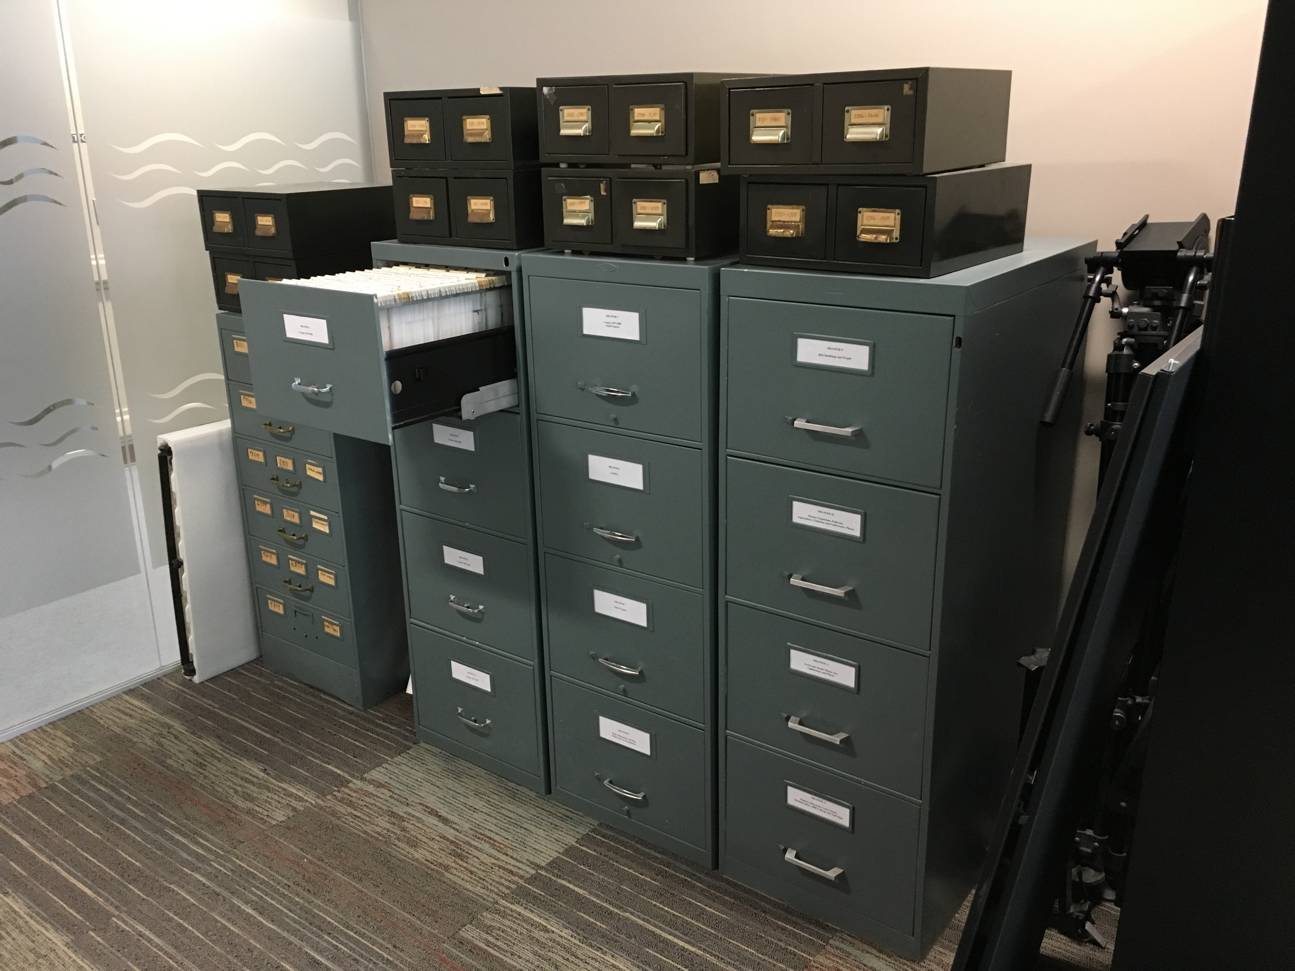

Anyone wanting to view the collection should make arrangements with Kelly Bentham. Pages can be easily removed from the filing cabinets and viewed on a nearby light table. Slides cannot be removed from the Photoshop but any selected images can be scanned on site. Since the slides were taken by Photoshop photographers, there are no copyright issues in using them.

DRAWER 1

Cruises
Hudson 70 12 pages
Summer
B. Pelletier (AGC)
Arctic Leg and return to BIO
Geology
Hudson 76-023 3 pages
23 July-19 Aug 1976
R. Falconer (AGC)
Eastern Arctic
Geology
Hudson 77-024 20 pages
22 Aug-17 Sept 1977
P. Jones (AOL)
Eastern arctic and Labrador Sea
Chemical data collection, investigation of oil seep area near Scott Inlet
Hudson 78-009 5 pages
17 Sept-23 Oct 1978
B. McLean (AGC)
Baffin Island Shelf and Baffin Bay
Geophysical and geological studies
Hudson 78-026 21 pages
25 Aug-16 Sept 1978
E. Levy (AOL)
Scott Inlet, Buchan Gulf, Lancaster Sound, Melville Bay
Arctic oil seeps
Hudson 79-017 10 pages
13 June-31 July 1979
C. Schafer (AGC)
West of Orphan Knoll
Marine geological process studies

Hudson 81- 001 6 pages
27 Feb-16 March 1981
R. Pocklington (AOL)
BIO to Colon, Panama
Multidisciplinary investigations, BIOSTAT project
Hudson 81-017 4 pages
16-30 May
R. Chase (UBC)
Juan de Fuca Ridge and Explorer Seamount off Vancouver Island
Geological and geochemical studies and drilling of basalt cores
Hudson 81-045 16 pages
1 Oct-4 Nov 1981
M. Lewis (AGC)
Eastern Arctic, Grand Banks
Geological and geophysical studies
Hudson 82-018 12 pages
15 June-5 July 1982
D. Buckley (AGC)
Nares Abyssal Plain
Study history of deposition and geochemical reactivity of deep-sea sediments
Hudson 82-054 6 pages
18 Oct-2 Nov 1982
H. Josenhans (AGC)
Labrador Shelf
Surficial geology surveys

DRAWER 2

Hudson 83-019 9 pages
8-15 July 1983
G. Fader (AGC)
Bedford Basin, Scotian Shelf and slope
Testing Seabed II mapping system, sidescan sonar surveys, seabed sediment sampling
Hudson 83-028 33 pages
19 September-5 October
J. Syvitski (AGC)
Baffin Island fjords
Climatology, sediment dynamics, animal-sediment interrelationships and other studies
Hudson 83-030 7 pages
5-26 October 1983
G. Vilks (AGC)
Labrador Shelf, Lake Melville
Sediment sampling, seismic surveys and chemical studies of petroleum-related substances
Needler N021 1984 2 pages
16-22 Jan 1984
L. Dickie (MEL)
Scotian Shelf
Testing ECOLOG acoustic fish counting system
Hudson 84-029 3 pages
18-25 July 1984
G. Fader (AGC)
Bedford Basin, Scotian Shelf and slope
Testing Seabed II deep ocean mapping system, sidescan sonar surveys, seabed sediment sampling, evaluating Hydrostar range bearing receiver, sidescan sonar surveys, seabed sediment sampling and photographs
Hudson 85-001 5 pages
18-29 March 1985
D. Piper (AGC)
Laurentian Fan and Fogo Seamounts
Investigating seabed stability
Hudson 85-005 3 pages
31 March-24 April 1985
G. Fader (AGC)
Grand Banks and Avalon Channel
Map surficial bedrock geology and carry out NORCO rock core drill and acoustic positioning tests
Dawson 85-015 5 pages
1-14 June 1985
D. Sameoto (MEL)
Scotian Shelf and Banquereau Bank
Distribution of chlorophyll and zooplankton
Hudson 85-027 15 pages
23 Sept-27 Oct 1985
B. MacLean (AGC)
Davis Strait, Baffin Bay and Hudson Strait
Surficial samples for paleoecological studies, surficial and shallow bedrock mapping and sampling using rock core drills and high resolution seismic techniques
Baffin 85-029 7 pages
1-13 October 1985
C. Ross (AOL)
Baffin Bay, Dolphin
Baffin Bay circulation
Baffin 85-033 4 pages
Dolphin

Dawson 86-011 6 pages
9-19 May 1986
K. Frank (BSB)
Brown’s Bank and Bay of Fundy
Ichthyoplankton dynamics
Hudson 86-017 5 pages
18-28 June 1986
G. Fader (AGC)
Whale Deep, Avalon Channel, Halibut Channel, Haddock Channel, Green Bank, Grand Banks
Surficial and shallow bedrock geology for surficial mapping of proposed pipeline corridors
Hudson 86-027 16 pages
26 Aug-25 Sept 1986
B. MacLean (AGC)
Wellington Channel, Byam Martin Channel, Viscount Melville, Prince Regent , Barrow Strait areas
Collection of physical, geophysical, geotechnical, biological, physical oceanography and hydrographic data
Hudson 86-040 2 pages
21-31 Oct 1986
H. Josenhans (AGC)
Hudson Bay
Correlation of glacial stratigraphy and geomorphology, and deglaciation of the Laurentide Ice Sheet
Needler 1987 2 pages

DRAWER 3

Hudson 87-003 5 pages
3-14 April 1987
K. Manchester/L. Mayer (AGC)
Emerald Basin, Laurentian Fan
Conduct seismic surveys and test new modified equipment
Dawson 87-024 3 pages
30 June-11 July 1987
D. McKeown (PCSB)
Scotian Shelf
Gear testing
Hudson 87-028 12 pages
3-21 Aug 1987
H. Josenhans (AGC)
Hudson Bay
Vertical and laterial distribution of surficial and subsurface geological units, seafloor and paleosediment dynamics

Dawson 88-041 8 pages
23-30 Nov 1988
K. Kranck (PCSB)
Bay of Fundy
Sedimentation studies
Dawson 89-006 5 pages
4-18 May 1989
G. Fader (AGC)
Northwest Grand Banks
Geophysical study of near-shore surficial sediments and bedrock mapping
Baffin 89-008 2 pages
29 May-23 June 1989
H. Josenhans/R. Parrot (AGC)
Gulf of St. Lawrence and Scotian Shelf
Geophysical survey and high resolution seismics
Baffin 89-014 1 page
14-19 July 1989
B. Long (IRNS)
Lake Melville, Labrador
Geophysical survey, underwater photography, sediment sidescan bathymetric mapping, ADFEX project
Hudson 89-039 6 pages
18-30 March 1989
C. Amos (AGC)
Georges Bank
Sediment transport studies
ROV 89 14 pages
ROV 90 5 pages
Baffin 90-006 13 pages
9 May-6 July 1990
C. Rockwell (CHS)
Bonavista Bay
Hydrographic charting
Hudson 90-028 9 pages
30 Oct-17 Nov 1990
H. Josenhans (AGC)
Gulf of St. Lawrence
Geophysics, Quaternary geology
Hudson 91-061 12 pages
24 Feb-18 March 1991
C. Tang (PCSB)
Northeast Newfoundland Shelf
Ice margin study

Hudson 92-001 6 pages
6-16 April 1992
C. Amos (AGC)
Georges Bank
Geophysics
Hudson 92-003 4 pages
21 Apr-1 May 1992
D. Buckley (AGC)
Scotian Shelf
Geology, piston core tests
Hudson 92-028 15 pages
5 Aug-12 Sept 1992
C. Amos/B. MacLean (AGC)
Hudson Bay/Great Whale River
Environmental geology

DRAWER 4

Parizeau 92-031 13 pages
19-29 August 1992
D. McKeown (PCSB)
Scotian Shelf
Gear trials
Parizeau 92-034 6 pages
1-13 Sept 1992
T. Rowell (BSB)/P. Schwinghamer (NAFC)
Grand Banks, Scotian Shelf
Trawl impact studies
Oceanus (US) 2 pages
26 Oct-19 Nov 1992
N. Oakey (PCSB)
Canary Basin
North Atlantic tracer release experiment and microstructure studies
Hudson 93-016 5 pages
10-16 June 1993
C. Amos (AGC)
Sable Island Bank
Seabed sediment stability
Parizeau 93-021 7 pages
28 June-16 July 1993
T. Rowell (BSB)/P. Schwinghamer (NAFC)
Grand Banks
Otter trawling experiment

Parizeau 93-029 8 pages
4-21 Sept 1993
T. Rowell (BSB)
Grand Banks
Otter trawling experiment
Hudson 93-030 14 pages
3-17 Sept 1993
J. Syvitsky (AGC)
East Greenland/western Iceland Shelf
Geology and geophysical surveys
Moresby 3 pages
27 Sept-8 Oct 1993
G. Fader (AGC)
Scotian Shelf
Sidescan sonar survey of coastal area to map surficial geology
Parizeau 94-015 7 pages
4-21 July 1994
T. Rowell (BSB)
Grand Banks
Otter trawling experiment
Hudson 94-027 5 pages
15 Aug-2 Sept 1994
- Grant (GSCA)
Laurentian Trough
Geophysics
Hudson 95-006 6 pages
23 May-3 June 1995
H. Josenhans (GSCA)
Cabot Straight
Geophysics
Parizeau 95-013 8 pages
19 June-12 July 1995
T. Rowell (BSB)
Grand Banks
Otter trawling experiment
Parizeau 95-028 4 pages
10-18 Oct 1995
D. Sameoto (BSB)
Scotian Shelf
Zooplankton studies
Parizeau 96-009 6 pages
1-15 June 1996
D. Gordon (MESD)
Scotian Shelf
PERD and fishing gear impacts

Templeman 192/96 3 pages
Needler N05 1997 2 pages
Needler N241 1997 5 pages
Parizeau 97-013 4 pages
23 May-6 June 1997
D. Belliveau (OSD)
Sable Island Bank, Cabot Strait and Eastern Shore
Engineering trials, suspended sediment studies and optical plankton counter
Hudson 97-020 3 pages
16 June-4 July 1997
G. Fader (GSCA)
Seabed mapping, sediment transport and erosion
Bay of Fundy, Browns Bank

DRAWER 5

Matthew 97-045 11 pages
3 Sept-10 Oct 1997
B. MacGowan (CHS)
Bonavista Bay, NL
Hydrography
Parizeau 97-053 (two legs) 11 pages
27 Sept-20 Oct 1997
D. Gordon/K. Muschenheim (MESD)
Grand Banks, Scotian Shelf
PERD and fishing gear impacts
Matthew 98-005 6 pages
27 April-24 June 1998
South coast of Newfoundland
Hydrography
Hudson 98-015 (two legs) 17 pages
22 May-16 June 1998
D. Gordon/K. Muschenheim (MESD)
Grand Banks, Scotian Shelf
PERD and fishing gear impacts
Parizeau 98-??? 1 page
Nov??
Transportation Safety Board?
Swiss Air crash site off Peggy’s Cove
Benthic surveys and recovery of wreckage
Hudson 99-012 (two legs) 16 pages
12 May-6 June 1999
D. Gordon/K. Muschenheim (MESD)
Grand Banks, Scotian Shelf
PERD and fishing gear impacts

Hudson 00-020 (two legs) 24 pages
11 June-7 July 2000
K. Muschenheim/D. Gordon (MESD)
Grand Banks, Scotian Shelf
PERD and fishing gear impacts
Hudson 00-047 3 pages
9-23 September 2000
B. Todd (GSCA)
Southern Scotian Shelf, Georges Bank, Northeast Channel
Geophysical and geological seabed surveys

Field Projects
Operation Oil (BIO) 1970 2 pages
St. Margaret’s Bay (MEL) 1 page
Canso 1973 (AGC) 11 pages
Cunningham Inlet, NWT, July 1977 (CHS) 12 pages

DRAWER 6

LOREX 1979 (Lomonosov Ridge Experiment) 101 pages
14 March-15 June 1979
J. Weber (DEMR Ottawa)
Arctic Ocean near North Pole
Nature and origin of Lomonosov Ridge (geophysics)
Main camp and two satellite camps on drifting pack ice

DRAWER 7

Cobequid Bay 1976 (AGC) 4 pages
Intertidal sediment transport studies
Cobequid Bay 1977 (AGC) 10 pages
Intertidal sediment transport studies
Miramichi 1977 (AOL) 13 pages
Labrador 1979 (CHS) 10 pages
Pecks Cove, Cumberland Basin 1980 (MEL) 7 pages
Resolute ~1985 (MEL) 3 pages
Sydney tar ponds May 77 1 page
Sydney tar ponds July 87 and Oct 88 (MEL/AOL) 5 pages
Minas Basin 1990 (BSB) 2 pages
ADFEX 1991 (AGC) 15 pages
Underwater explosion experiment

DRAWER 8

Ships
Acadia 5 pages
Maxwell 1 page
Baffin 3 pages
Hudson 9 pages
Prince 1 page
Navicula 1 page
Sigma t 1 page
Dawson 3 pages
Needler 2 pages
Matthew 3 page
Early sweep vessel 3 pages
Smith 7 pages
Creed 7 pages
Parizeau 1 page
Launches 2 pages
Hart 1 page
Berubé 1 page
Cygnus 1 page
Martha Black 1 page
Chebucto 1 page
Louisbourg 1 page
Louis St. Laurent 1 page
Edward Cornwallis 1 page
Port Bickerton 1 page
Other CCG vessels 1 page
Alert 1 page
North Bar 1 page
Visiting ships to BIO 2 pages
Miscellaneous ships 7 pages

Helicopters
2 pages

Oil Rigs
2 pages

Shipwrecks
1 page

Equipment
Miscellaneous 25 pages
Nikon F45 system 1 page
Radio-controlled launch 1 page
EMS 6 pages
GPS Man Pack 1 page
Mixed Layer Dissipation 1 page
EM3000 2 pages
Smart Trap 2 pages
Portable Arctic Winch 1 page
Batfish 2 pages
Dolphin 12 pages
Videograb 2 pages
BRUTIV 1 page
BOSS 1 page

DRAWER 9

BIO
Buildings 21 pages
People 35 pages
Fisheries Officer Training 9 pages

DRAWER 10

Marine Organisms
General 4 pages
Zooplankton 1 page
Benthos (including corals) 8 pages
Fish 23 pages
Mammals 4 pages
Seabirds 1 page

Fisheries
34 pages

Aquaculture
5 pages

Pollution
5 pages

Underwater Photos
2 pages

DRAWER 11

Aerial Photos - Halifax
8 pages
Aerial Photos – NS, NB, PEI, NL
36 pages
Scenic Photos
19 pages

Ice
2 pages
Icebergs
4 pages

Lighthouses
2 pages
Places
|Magdalen Islands, QC 1 page
Red Bay, NL 1 page
St. John’s, NL 1 page
Sable Island 35 pages
Brier Island 5 pages
St. Andrews 1 page
Lawrencetown 1 page
Kuwait Institute for Scientific Research (KISR) (Feb 1990) 2 pages

DRAWER 12

Figures (maps, charts, posters, diagrams, etc.)
23 pages

Historical
2 pages

Coast Guard
3 pages

Boating Safety
2 pages

DREA Barge
2 pages

Tall Ships 2000
5 pages

